Veterinary Clinical Complex
Nagpur Veterinary College, Nagpur
North Ambazari Road, Near Alankar Theatre, Dharampeth, Nagpur

World Rabies Day Celebrated at Veterinary Clinical Complex
To mark World Rabies Day 2025, the Veterinary Clinical Complex at Nagpur Veterinary College organized a “Free Anti-Rabies Vaccination and Public Awareness Campaign” during clinical hours. The event aimed to raise awareness about rabies prevention and promote responsible pet ownership. This year’s global theme, “Act Now: You, Me, Community”, emphasized the collective responsibility in eliminating rabies and protecting both human and animal lives. The camp witnessed active participation from pet owners, students, and the general public, with free vaccinations administered and informative sessions conducted by veterinary professionals. On this occasion, Dr. N.V. Kurkure (Director of Research, MAFSU), Dr. S.W. Bonde (Director of Exnsion, MAFSU), Mr. S.N. Gawande (University Librarian, MAFSU), Dr. J. P. Korde (Associate Dean, NVC, Nagpur) and Dr. S.B. Akhare (Head VCC, NVC) were present on the dais.
Dr. J.P. Korde (Associate Dean, NVC, Nagpur) welcomes Dr. N.V. Kurkure (Director of Research, MAFSU) and Dr. S.W. Bonde (Director of Extension, MAFSU) by offering a floral bouquet. Dr. S.B. Akhare, Head, VCC welcomes Dr. J.P. Korde, (Associate Dean, NVC, Nagpur) and Mr. S.N. Gawande (University Librarian, MAFSU) by offering a floral bouquet. Dr. N. V, Kurkure (Director of Research, MAFSU, Nagpur) guided all the audience about rabies disease. Total 55 pets were vaccinated against rabies. The clinical faculty at the hospital was present during free Anti Rabies vaccination camp. The vaccination camp was supported by the pharmaceutical company M/S Drools Pet Food PVT. LTD. Pet owners were supplied with Pet food supplements. The undergraduate, post-graduate and intern students (Nagpur Veterinary College, College of Veterinary Science and Animal Husbandry, Jabalpur and College of Veterinary Science and Animal Husbandry, Anjora, Durg) were present in large number on the occasion.
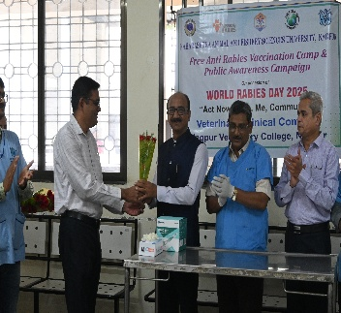 | 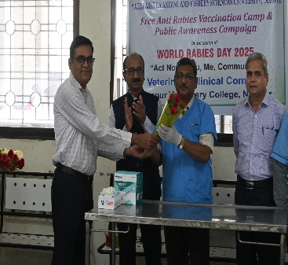
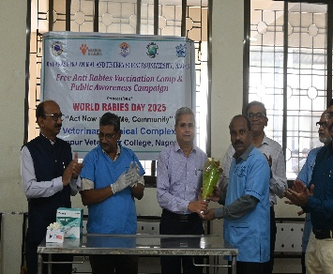 | 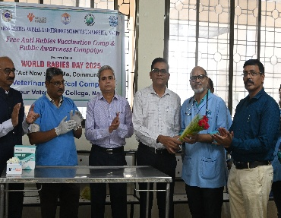
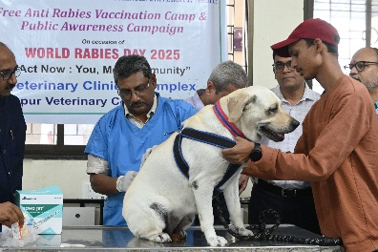 | 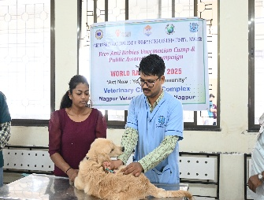
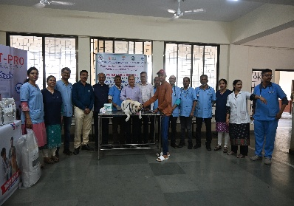 | 